Add below jars

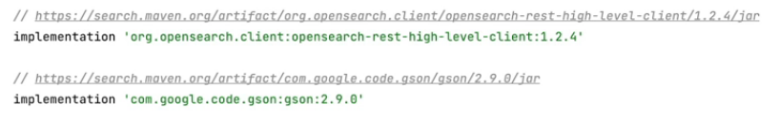

Goto bonsai.io 🡪goto Free sandbox cluster—Fill all contact details create a cluster name

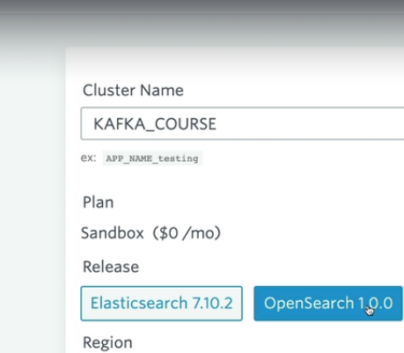choose your nearest cluster